**NAME: OYEDAYO OYELOWO STUDENT NUMBER: 014717208**

**EXERCISE 1: 3D POINT DATA IN R AND DTM DERIVATION**

The main idea of this practical is to get familiar with data structures of LiDAR data and generate DTMs.

It is highly recommended to bear in mind the question that what is happening and connect it with

lecture notes. Critical thinking is more important than just hitting “run” on the R scripts.

1. How many laser returns data includes in 2006, 2007, and 2010?

There were 79,466 laser returns in 2006.

(Fi:18 935, In: 2601, La:18 935, Si:38 995)

There were 121,881 laser returns in 2007

(Fi:27 030, In: 3 549, La:27 030, Si:64 272)

There were 306,977 laser returns in 2010

(Fi: 67 577, In: 7428, La: 67 577, Si: 164 395)



2. How many first returns data from 2007 includes?

There are 27, 030 first returns data from 2007.

3. Which is the lowest elevation in the area in 2006?

The lowest elevation in the area in 2006 is about 178.6m

Min. :178.6

4. Calculate the first (first+single) pulse densities for 2006, 2007 and 2010.

Pulse/area of the plot

The pulse density for 2006 is about 6.442826

Pulse density in 2007= 10.15437

Pulse density in 2010 = 25.79933

5. Plot height distributions for first and last returns at 5% intervals using 2006 data.

a. Add height distribution figures

**FIRST**

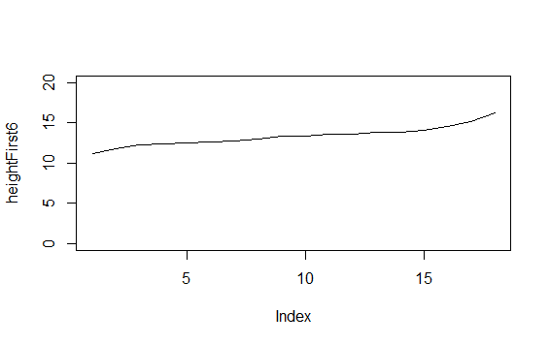

**LAST**

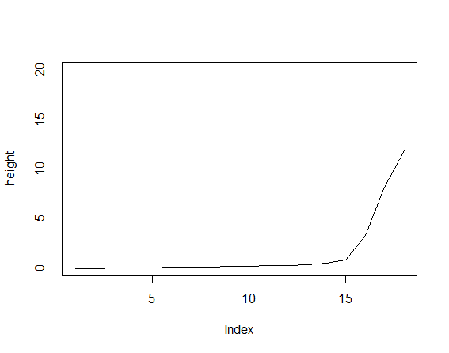

b. What kind of differences you can find?

The first is higher all through, apparently, because the pulses(first returns) return from the top of the object(e.g.: vegetation) while the last has lower heights because the pulses(last return) come back from the ground before it peaks up.

6. Calculate the average flying height for 2006, 2007 and 2010?

Average flying height in 2006 :819.0m

Average flying height in 2007 :751.2m

Average flying height in 2010 :1600m

7. Create DTM maps with 8 m, 4 m, 2 m and 1 m and 0.5 m resolutions based on 2006 ALS data.

8m 4m

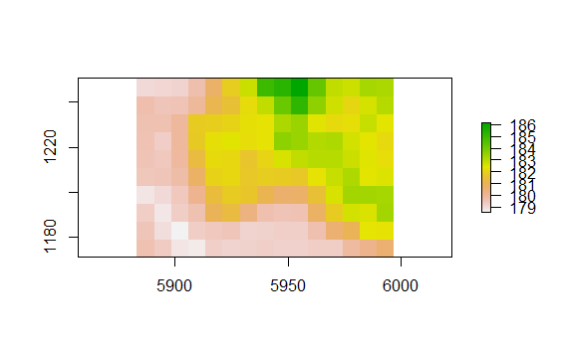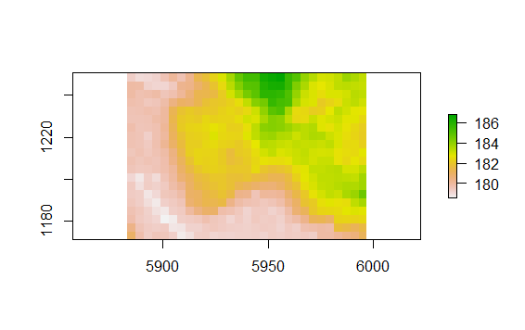

2m 1m

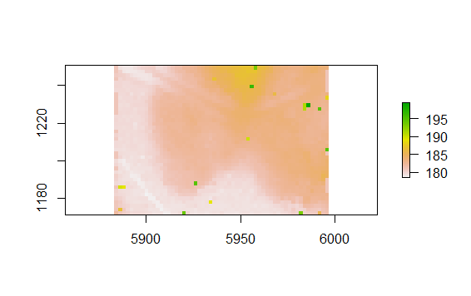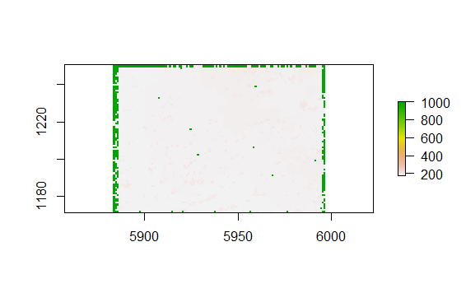

0.5m

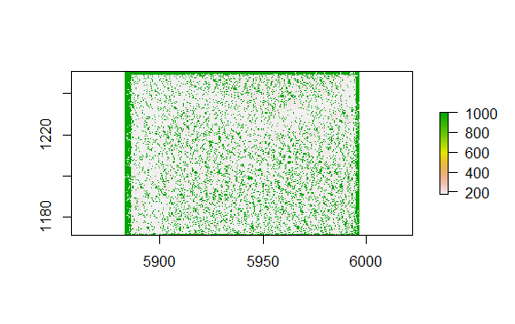

8. Calculate maximum height differences between various DTMs based on 2006 ALS data

a. 8 m vs. 0.5 m

3.215749m

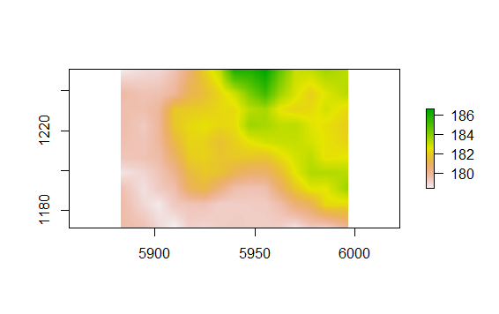

b. 4 m vs. 0.5 m

3.322216

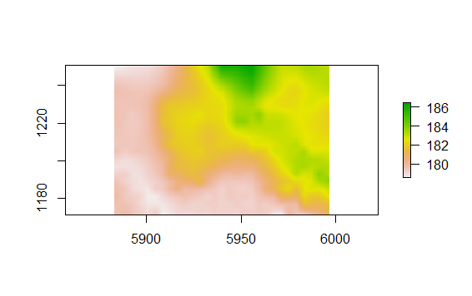

c. 2 m vs. 0.5 m

1.592508

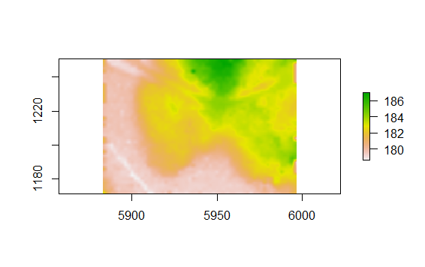

d. 1 m vs. 0.5 m

0.7996934

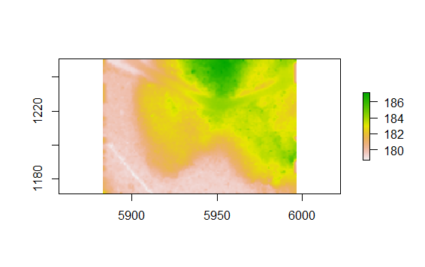

9. Which is the lowest/highest surface return based on DTM (grid 0.5) using 2006 data?

layer

Min. 178.5800

Max. 1000.0000

Return your answers to MOODLE (PDF-document) before 21.9 at 23.55.